Thejasvenan T. 220638J
ME 2261 - Embedded Systems Log Book
Day 14 – 24.10.2025
Task 1
Toggle LED every 50 ms which is connected to PC0 by using Timer Zero (Timer 0). The CPU clock frequency is 8 MHz.
Methodology – Using interrupts
Prescalers | F_clock | Timer count
8 | 1 MHz | 49999 | Timer 0 is a 8 bit timer counter.
64 | 125 KHz | 6249
256 | 31.25 KHz | 1561.5 | Not an integer num
1024 | 7812.5 Hz | 389.625
Prescaler = 64, Timer Counter = 6249
Timer 0 is the 8 bit counter. After every 256 tick timer overflow. Therefore, timer has overflow 24 times.
Remaining time count = 6249 – (24*256) = 105
Thus, in the 25th iteration, we only allow the timer to count up to 105, and then reset it.

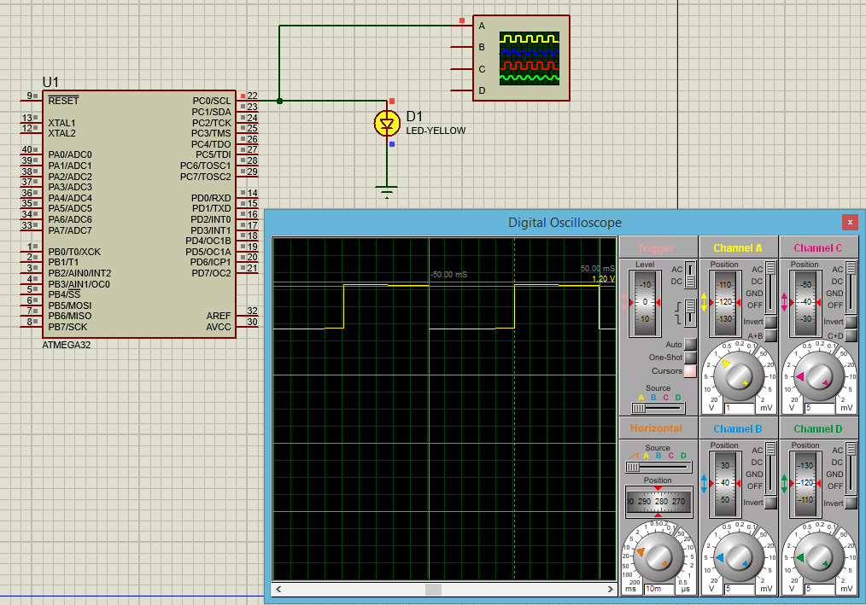
#define F_CPU 8000000UL
#include <avr/io.h>
#include <avr/interrupt.h>
#include <util/delay.h>

volatile uint16_t tot_overflow;

void timer0_init()
{
TCCR0 |= (1 << CS01)|(1 << CS00); // prescaler = 64
TCNT0 = 0; // Initialize counter
TIMSK |= (1 << TOIE0); //
sei(); // enable global interrupt
tot_overflow = 0; // set number of overflow to 0
}

ISR(TIMER0_OVF_vect){
tot_overflow++; // keep a track of number of overflows
}

int main(void){

DDRC |= (1 << 0); // connect led to pin PC0
timer0_init();
while(1){
if (tot_overflow >= 24) // check the number of overflows = 24
{
if (TCNT0 >= 105 ) // check if the timer count reaches 105
{
PORTC ^= (1<<0); // toggles the led
TCNT0 = 0; //reset counter
tot_overflow = 0; // reset overflow count
}
}
}
}

Task 2
Using TIMER0 generate the following frequency signal. Methodology using Interrupts.
On – 10 ms
For prescaler 64, timercounter = 1249, timer has overflow 4 times.
Remaining time count = 1249 – (4*256) = 225
In 5th iteration, we have to count until 225, and reset it.
Off – 20 ms
For prescaler 64, timercounter = 2499, timer has overflow 4 times.
Remaining time count = 2499 – (9*256) = 195
In 10th iteration, we have to count until 195, and reset it.
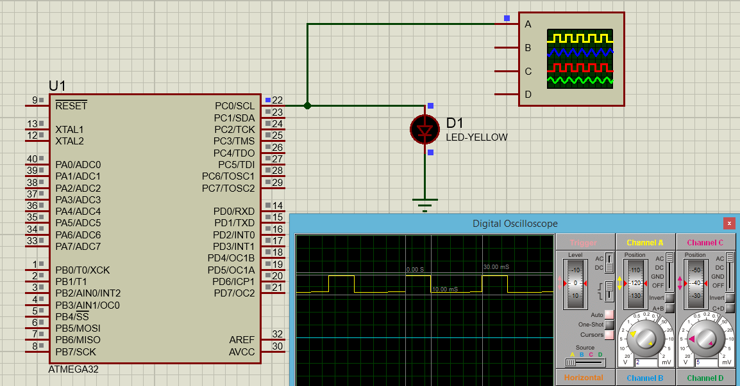

#define F_CPU 8000000UL
#include <avr/io.h>
#include <avr/interrupt.h>
#include <util/delay.h>

volatile uint16_t tot_overflow;

void timer0_init()
{
TCCR0 |= (1 << CS01)|(1 << CS00); // prescaler = 64
TCNT0 = 0; // Initialize counter
TIMSK |= (1 << TOIE0); //
sei(); // enable global interrupt
tot_overflow = 0; // set number of overflow to 0
}

ISR(TIMER0_OVF_vect){
tot_overflow++; // keep a track of number of overflows
}

int main(void){
DDRC |= (1 << 0); // connect led to pin PC0
timer0_init();
while(1){
if (tot_overflow >= 4 && PORTC == 1)
{
if (TCNT0 >= 225 )
{
PORTC = (0<<0); // On the led
TCNT0 = 0; //reset counter
tot_overflow = 0; // reset overflow count
}
}
if (tot_overflow >= 9 && PORTC == 0)
{
if (TCNT0 >= 195 )
{
PORTC = (1<<0); // Off the led
TCNT0 = 0; //reset counter
tot_overflow = 0; // reset overflow count
}
}
}
}

Task 3
Generate 100 Hz signal whose on-time(ms) is set by user input (0-9).
Methodology – Using interrupts and Timers
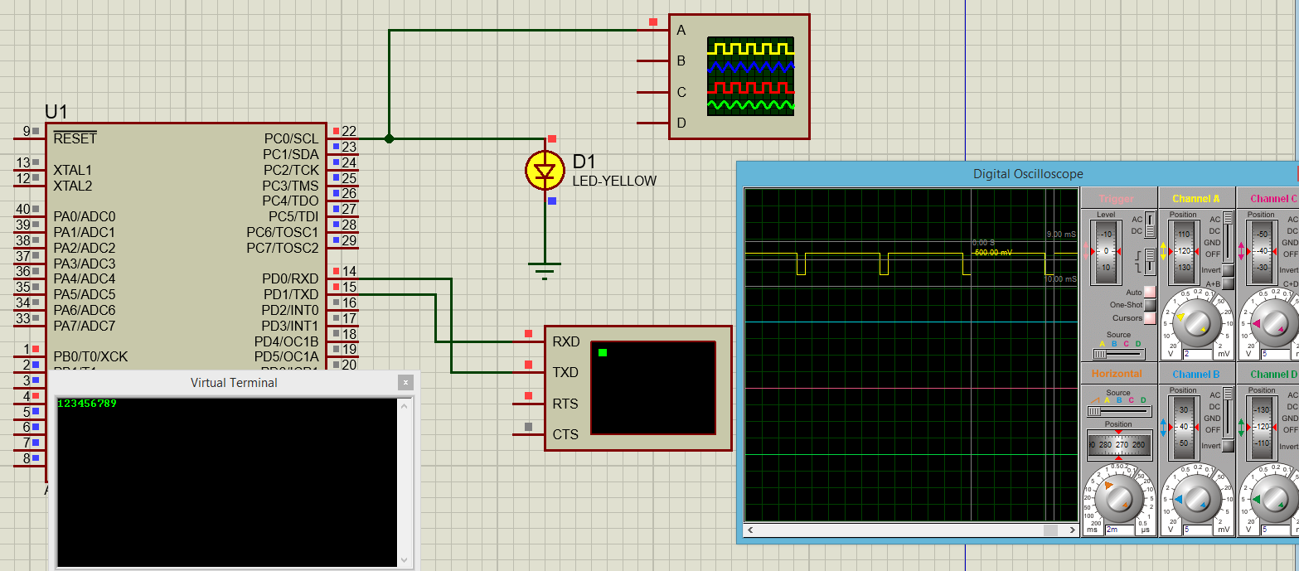
#define F_CPU 8000000UL
#include <avr/io.h>
#include <avr/interrupt.h>
#include <util/delay.h>

volatile uint16_t tot_overflow;

void USART_init(void) {
UCSRA = 0x00;
UCSRB = 0x98;
UCSRC = 0x86;
UBRRL = 0x33;
UBRRH = 0x00;
}

void USART_send(unsigned char data){
while ((UCSRA & (1<<UDRE))==0x00);
UDR = data;
}

unsigned char USART_receive(void){
while ((UCSRA & (1<<RXC))==0x00);
return UDR;
}

ISR(USART_RXC_vect) {
unsigned char data = USART_receive();
USART_send(data);
PORTB = data-'0'; // Convert ASCII to Number
}

void timer0_init()
{
TCCR0 |= (1 << CS01)|(1 << CS00); // prescaler = 64
TCNT0 = 0; // Initialize counter
TIMSK |= (1 << TOIE0); //
sei(); // enable global interrupt
tot_overflow = 0; // set number of overflow to 0
}

ISR(TIMER0_OVF_vect){
tot_overflow++; // keep a track of number of overflows
}

void step_count(int num, int *iteration, int *steps) {
int count = num * 125 - 1; // for prescaler 64
*iteration = count / 256;
*steps = count % 256;
}

int main(void){
USART_init();
sei();
DDRB = 0xFF;
DDRC = 0xFF;
DDRC |= (1 << 0); // connect led to pin PC0
timer0_init();
while(1){
int num = PORTB;
int on_i, on_s, off_i, off_s;
if (PORTB>0 && PORTB<10){
step_count(num, &on_i, &on_s);
step_count(10-num, &off_i, &off_s);
if (tot_overflow >= on_i && PORTC == 1)
{
if (TCNT0 >= on_s )
{
PORTC = (0<<0); // On the led
TCNT0 = 0; //reset counter
tot_overflow = 0; // reset overflow count
}
}
if (tot_overflow >= off_i && PORTC == 0)
{
if (TCNT0 >= off_s )
{
PORTC = (1<<0); // Off the led
TCNT0 = 0; //reset counter
tot_overflow = 0; // reset overflow count
}
}
}
}
}

Task 4
Using only hardware timers, generate 100 Hz digital signal on a GPIO pin. The user will enter an on-time (0-10 ms) using two push-buttons (INC/DEC). The output is a 100 Hz waveform (period = 10 ms) whose ON duration equals the entered on-time. Measure and report accuracy.
Using Interrupts and timers.
#define F_CPU 8000000UL
#include <avr/io.h>
#include <avr/interrupt.h>
#include <util/delay.h>

volatile uint16_t tot_overflow;

void timer0_init()
{
TCCR0 |= (1 << CS01)|(1 << CS00); // prescaler = 64
TCNT0 = 0; // Initialize counter
TIMSK |= (1 << TOIE0); //
sei(); // enable global interrupt
tot_overflow = 0; // set number of overflow to 0
}

ISR(TIMER0_OVF_vect){
tot_overflow++; // keep a track of number of overflows
}

void step_count(int num, int *iteration, int *steps) {
int count = num * 125 - 1; // for prescaler 64
*iteration = count / 256;
*steps = count % 256;
}

ISR (INT0_vect)
{
if (PORTB!=10){PORTB = PORTB+1;}
else
PORTB=0;
}

ISR (INT1_vect)
{
if (PORTB!=0){PORTB = PORTB-1;}
else
PORTB=10;
}

int main(void){
sei();
DDRB = 0xFF;
GICR = (1<<INT1) | (1<<INT0);
MCUCR = (1<<ISC10) | (1<<ISC11);
int num = 0;
DDRC = 0xFF;
DDRC |= (1 << 0); // connect led to pin PC0
timer0_init();
do{
num = PORTB;
int on_i, on_s, off_i, off_s;
step_count(num, &on_i, &on_s);
step_count(10-num, &off_i, &off_s);
if (tot_overflow >= on_i && PORTC == 1)
{
if (TCNT0 >= on_s )
{
PORTC = (0<<0); // On the led
TCNT0 = 0; //reset counter
tot_overflow = 0; // reset overflow count
}
}
if (tot_overflow >= off_i && PORTC == 0)
{
if (TCNT0 >= off_s )
{
PORTC = (1<<0); // Off the led
TCNT0 = 0; //reset counter
tot_overflow = 0; // reset overflow count
}
}
}while(PORTB<11);
}

